

**VR App Manual using Unity**

# Introduction

This document will guide you on how to add new patterns and new colours to VR app.

# Add new pattern and new colour

1. **Prepare pattern prefab**
   1. Import image into Patterns folder, create a new material and attach the image to the material
   2. Create a sphere gameObject named with pattern/colour name with scale of 10*10*10
   3. Attach the created material and VRController script to the gameObject
   4. Drag the corresponding material to “New Material Ref” and the gameObject to “Clicked Object”

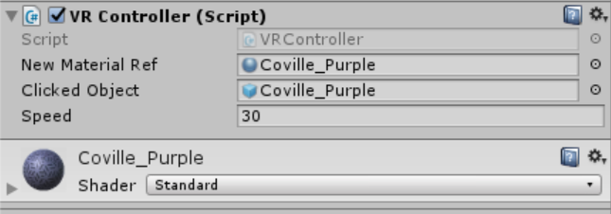

* 1. Create a new Tag with gameObject name and assign the newly created tag
     1. Click the Tag and scroll to the bottom to add new tag

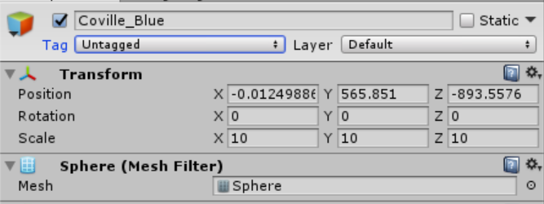

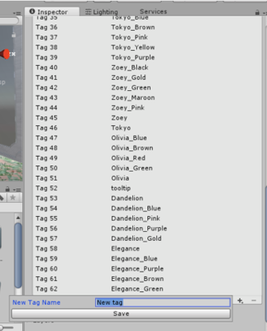

* 1. Create a prefab and attach the gameObject to the prefab

1. **Modify the scripts**

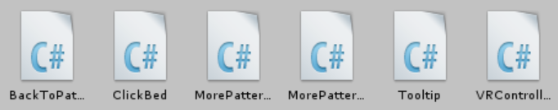

* 1. **VRController**

Add new pattern name into patterns array

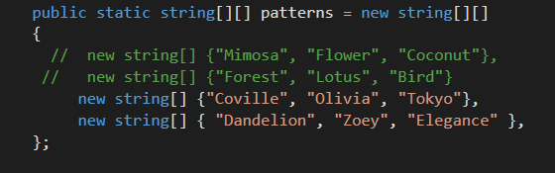

Create a new colour array for the new pattern

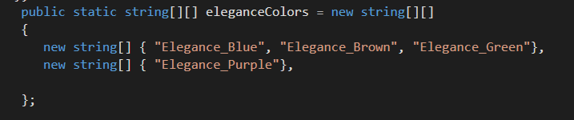

Modify OnGazeTrigger() to instantiate colours once the pattern is clicked

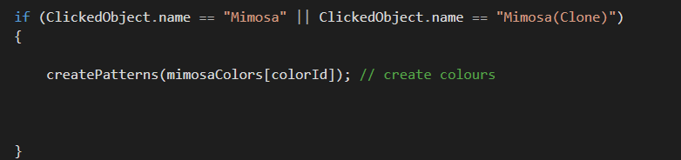

1. **Modify MorePatternsToLeft and MorePatternsToRight to scroll to more colours**

Scroll colour selection to the left

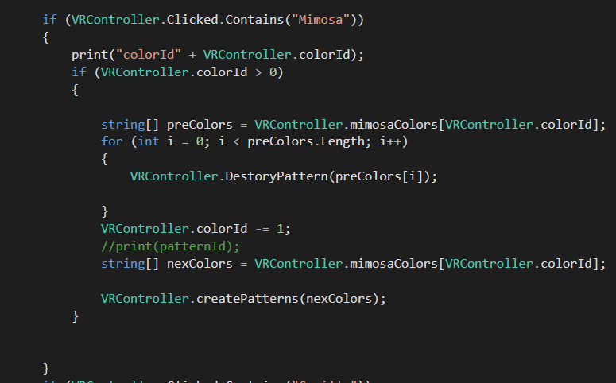

Scroll colour selection to the right

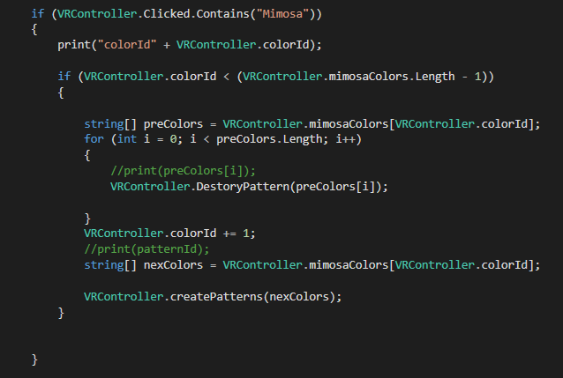

1. **Modify BackToPatterns to destroy colour gameObjects when back to pattern menu**

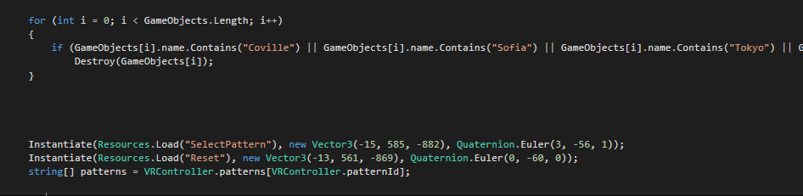

1. **Modify ClickBed to destroy new patterns when resetting the scene**

